|  |  |
| --- | --- |
| COLOUR_LOGO Aug 2010 | **YEAR 12 ATAR PHYSICS UNIT 3 and 4**  **SEMESTER TWO EXAMINATION 2018** |
| |  |  | | --- | --- | | **Teacher:** | W O’CALLAGHAN / K ROURKE | |

(Circle)

|  |  |  |  |  |  |  |  |  |  |  |  |
| --- | --- | --- | --- | --- | --- | --- | --- | --- | --- | --- | --- |
| **Student Number:** In figures | |  |  |  |  |  |  |  |  |  |  | | --- | --- | --- | --- | --- | --- | --- | --- | --- | --- | |  |  |  |  |  |  |  |  |  |  | |

In words \_\_\_\_\_\_\_\_\_\_\_\_\_\_\_\_\_\_\_\_\_\_\_\_\_\_\_\_\_\_\_\_\_\_\_\_\_\_\_\_\_\_\_\_\_\_\_\_

\_\_\_\_\_\_\_\_\_\_\_\_\_\_\_\_\_\_\_\_\_\_\_\_\_\_\_\_\_\_\_\_\_\_\_\_\_\_\_\_\_\_\_\_\_\_\_\_

|  |  |  |
| --- | --- | --- |
| **Time allowed for this paper** | Reading time before commencing work: | 10 minutes |
|  | Working Time: | 3 hours |

**Materials required/recommended for this paper**

***To be provided by the supervisor*** This Question/Answer Booklet

Formulae and Constants Booklet

***To be provided by the candidate***

Standard items: pens, pencils, eraser, correction fluid/tape, ruler, highlighters

Special items: non-programmable calculators approved for use in the WACE examinations, drawing templates, drawing compass and a protractor

**Important note to candidates**

No other items may be taken into the examination room. It is **your** responsibility to ensure that you do not have any unauthorised notes or other items of a non-personal nature in the examination room. If you have any unauthorised material with you, hand it to the supervisor **before** reading any further.

**Structure of this paper**

|  |  |  |  |  |  |
| --- | --- | --- | --- | --- | --- |
| Section | Number of questions available | Number of questions to be answered | Suggested working time  (minutes) | Marks available | Percentage of exam |
| Section One:  Short Answers | 11 | 11 | 50 | 60 | 30 |
| Section Two:  Problem-solving | 8 | 8 | 90 | 98 | 50 |
| Section Three:  Comprehension | 2 | 2 | 40 | 36 | 20 |
|  | | | | 194 | 100 |

**Instructions to candidates**

1. The rules for the conduct of examinations at Corpus Christi College are detailed in the College Examination Policy*.* Sitting this examination implies that you agree to abide by these rules.

2. Write your answers in this Question/Answer Booklet.

3. Working or reasoning should be clearly shown when calculating or estimating answers.

4. You must be careful to confine your responses to the specific questions asked and to follow any instructions that are specific to a particular question.

5. Spare pages are included at the end of this booklet. They can be used for planning your responses and/or as additional space if required to continue an answer.

* + - Planning: If you use the spare pages for planning, indicate this clearly at the top of the page.
    - Continuing an answer: If you need to use the space to continue an answer, indicate in the original answer space where the answer is continued, i.e. give the page number.

Fill in the number of the question(s) that you are continuing to answer at the top of the page.

6. Answers to questions involving calculations should be ***evaluated and given in decimal form*.** It is suggested that you quote all answers to ***three significant figures***, with the exception of questions for which estimates are required. Despite an incorrect final result, credit may be obtained for method and working, providing these are ***clearly and legibly set out***.

7. Questions containing the instruction *"****estimate****"* may give insufficient numerical data for their solution. Students should provide appropriate figures to enable an approximate solution to be obtained. Give final answers to a maximum of ***two significant figures*** and include appropriate units where applicable.

8. Note that when an answer is a vector quantity, it must be given with magnitude and direction.

9. In all calculations, units must be consistent throughout your working.

**Section One: Short response 30% (60 Marks)**

This section has **11** questions. Answer **all** questions.

Suggested working time: 50 minutes.

**Question 1 (3 marks)**

1. An object moves in a circle **in a counter-clockwise direction** with constant speed. On the diagram below draw and label the correct velocity and acceleration vectors for the object. (2 marks)

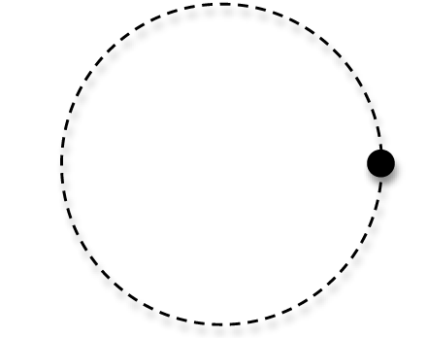

1. Which of the following diagrams correctly represents the force(s) acting on a satellite in a stable circular orbit around Earth? Circle the correct answer. (1 mark)

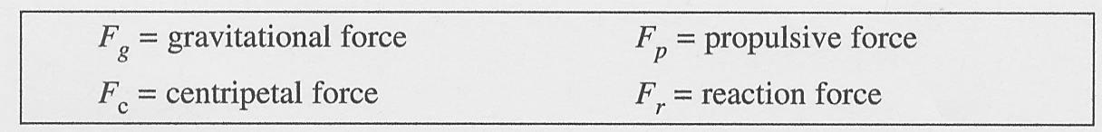

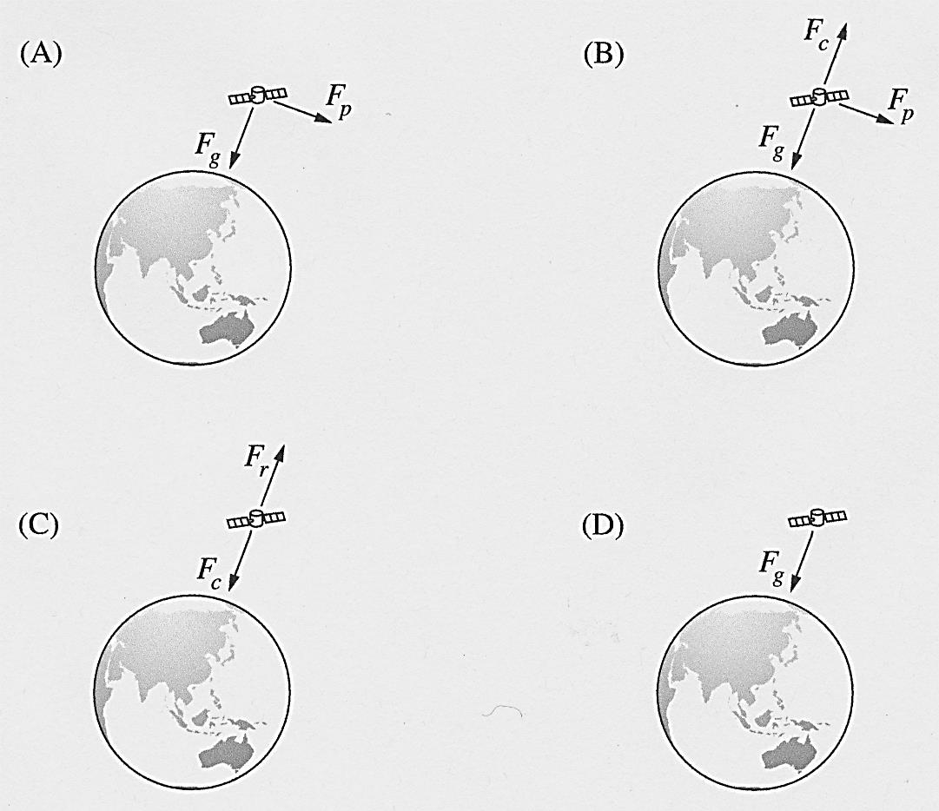

**Question 2 (5 marks)**

Digital television in New Zealand can be accessed by using a satellite dish pointed at a satellite in space. The satellite used to transmit the signals appears to stay still above the equator.

The satellite, with a mass of 300 kg, is actually travelling around the Earth in a geostationary orbit at a radius of 4.22 x 107 m from the centre of the Earth.

1. Calculate the force acting on the satellite. (2 marks)

..........................................................................................................................................

..........................................................................................................................................

..........................................................................................................................................

..........................................................................................................................................

1. Show that the speed of the satellite is about 3 x 103 m s–1. (3 marks)

..........................................................................................................................................

..........................................................................................................................................

..........................................................................................................................................

..........................................................................................................................................

..........................................................................................................................................

**Question 3 (5 marks)**

**Estimate** the force that is exerted on each arm when you execute a perfect push-up. You must provide all the relevant data and state all reasonable assumptions used in determining your answer. (Show all working details.)

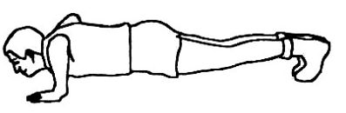

..........................................................................................................................................

..........................................................................................................................................

..........................................................................................................................................

..........................................................................................................................................

..........................................................................................................................................

..........................................................................................................................................

**Question 4 (5 marks)**

|  |  |
| --- | --- |
| 1. A triangular piece of wire is placed in a magnetic field as shown. | _Pic1 |

When current *I* is supplied as shown, how does the wire move? Circle the correct answer. (1 mark)

|  |  |  |
| --- | --- | --- |
|  | *Axis of rotation* | *Direction of movement* |
| A | YZ | Q into page |
| B | YZ | Q out of page |
| C | WX | R into page |
| D | WX | R out of page |

1. A current is sent through a helical coil spring, as shown in the diagram below. When the current is flowing the spring contracts, as though it had been compressed.

Explain why this is so. [Hint: Annotate and refer to the diagram in your answer or even draw an alternative diagram]. (4 marks)

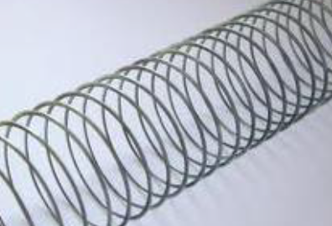

..........................................................................................................................................

..........................................................................................................................................

..........................................................................................................................................

..........................................................................................................................................

..........................................................................................................................................

..........................................................................................................................................

**Question 5 (5 marks)**

The diagram shows an electric circuit in a magnetic field directed into the page. The graph shows how the flux through the conductive loop changes over a period of 12 seconds.

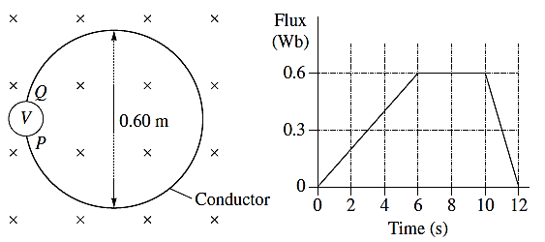

(a) Calculate the maximum magnetic field strength within the stationary loop during the

12-second interval. (2 marks)

..........................................................................................................................................

..........................................................................................................................................

..........................................................................................................................................

..........................................................................................................................................

1. Calculate the maximum voltage generated in the circuit by the changing flux. In your answer, indicate the direction of the induced current between the terminals *P* and *Q* when this occurs. (3 marks)

..........................................................................................................................................

..........................................................................................................................................

..........................................................................................................................................

..........................................................................................................................................

..........................................................................................................................................

**Question 6 (7 marks)**

An electron microscope uses a “magnetic lens” to focus a wide beam of electrons to a point as shown in the diagram. Assume that all electrons move with the same speed.

***B1***

***B2***

(a) Illustrate the directions of the magnetic fields *B1* and *B2* inside the triangular “magnetic” lenses

(1 mark)

1. Calculate the magnitude of the deflecting force on electrons travelling with a velocity of

1.50 x 106 ms-1 if the magnetic field strength is 0.100 T. (2 marks)

..........................................................................................................................................

..........................................................................................................................................

..........................................................................................................................................

1. (i) Calculate the de Broglie wavelength of an electron that has a velocity of 1.50 x 106 ms-1.

(1 mark)

..........................................................................................................................................

..........................................................................................................................................

(ii) Use this result to explain why an electron microscope is capable of much higher magnifications and has a greater resolving power than a light microscope, allowing it to see much smaller objects in finer detail. (3 marks)

..........................................................................................................................................

..........................................................................................................................................

..........................................................................................................................................

..........................................................................................................................................

..........................................................................................................................................

..........................................................................................................................................

**Question 7 (12 marks)**

A beam of 35.0 keV electrons strike a molybdenum target, generating X-rays.

(a) (i) Determine the cut-off wavelength of the X rays produced. **(λ min)** (3 marks)

..........................................................................................................................................

..........................................................................................................................................

..........................................................................................................................................

..........................................................................................................................................

(ii) Are these X-rays hard or soft? Give a possible use for these X-rays. (2 marks)

..........................................................................................................................................

..........................................................................................................................................

..........................................................................................................................................

1. Given that the power supplied to the X-ray tube in (a) is 18 kW, estimate how many X-ray photons would be produced in a 5.0 ms period of usage. (5 marks)

..........................................................................................................................................

..........................................................................................................................................

..........................................................................................................................................

..........................................................................................................................................

..........................................................................................................................................

..........................................................................................................................................

..........................................................................................................................................

..........................................................................................................................................

1. Multiple Choice (2 marks)
2. The main advantage of using X-rays produced by a synchrotron rather than X-rays produced in a conventional X-ray tube in an X-ray machine is that

**A** X-rays from an X-ray machine cannot be tuned using a monochromator.

**B** X-rays from an X-ray machine can only be used to investigate biological materials.

**C** the beamline of a synchrotron can produce an intense single-wavelength X-ray beam.

**D** radiation from a synchrotron will scatter more readily than the conventionally produced X-rays.

(ii) In the Australian Synchrotron, electrons are accelerated in several stages and their final speed approaches the speed of light.

Which of the following best describes the order in which the various components accelerate the electrons?

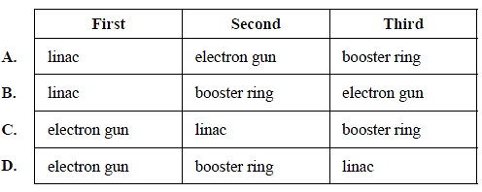

**Question 8 (3 marks)**

The wavelength of the Hβ line in the spectrum of the star Megrez in the constellation Ursa Major (the Great Bear) is 486.112 nm. Laboratory measurements demonstrate that the normal wavelength of this spectral line is 486.133 nm. Is the star coming towards us or moving away from us? Justify your answer. No calculation is required. (3 marks)

..........................................................................................................................................

..........................................................................................................................................

..........................................................................................................................................

..........................................................................................................................................

..........................................................................................................................................

..........................................................................................................................................

**Question 9 (3 marks)**

|  |  |
| --- | --- |
| An astronaut is floating freely in space in the Orion Nebula.  The astronaut is stationary and the view in the diagram (shown right) is what she sees from her faceplate.  A “Borg” spaceship, in the form of a cube is travelling at 20% of the speed of light (i.e. 0.2c) and is on a heading towards the astronaut *in the z direction*.  The dimensions of the Borg ship are labelled **Lo, Wo**, and **Ho** in the diagram. | **x**  **z**  **y**  **W0**      **H**  **0**    **L0** |

1. Which of the following options best describes the dimensions (**L, W** and **H**) of the box as observed by the astronaut outside the spaceship compared to the measurements made by the passenger?
2. L< Lo, W < Wo, H = Ho
3. L> Lo, W = Wo, H = Ho
4. L< Lo, W = Wo, H = Ho
5. L< Lo, W < Wo, H < Ho Answer: \_\_\_\_\_\_ (1 mark)
6. Carefully explain why you selected your answer. No calculation is required. (2 marks)

..........................................................................................................................................

..........................................................................................................................................

..........................................................................................................................................

..........................................................................................................................................

**Question 10 (5 marks)**

An alien spacecraft travelling at relativistic speed is flying overhead at a great distance as you stand in your backyard. You see its searchlight blink on for 1.20 s.

1. The alien first officer on the spacecraft measures that the searchlight is on for 0.19 s. What is the speed of the spacecraft relative to the earth expressed as a fraction of the speed of light?

(3 marks)

..........................................................................................................................................

..........................................................................................................................................

..........................................................................................................................................

..........................................................................................................................................

..........................................................................................................................................

..........................................................................................................................................

..........................................................................................................................................

1. How does Einstein’s Theory of Special Relativity explain the time difference of the blinks that we measure on Earth and what the alien measures on the spacecraft? (2 marks)

..........................................................................................................................................

..........................................................................................................................................

..........................................................................................................................................

..........................................................................................................................................

..........................................................................................................................................

..........................................................................................................................................

**Question 11 (7 marks)**

Towards the end of the 20th century scientists suggested that quarks were the basic building blocks of protons and neutrons. Classify the following sub-atomic particles as either Hadrons, Leptons or Neither.

(2 marks)

|  |  |  |  |
| --- | --- | --- | --- |
| Proton |  | Neutrino |  |
| Muon |  | Virtual photon |  |

1. A member of the ∑  group of particles consists of two *u* quarks and an *s* quark.
2. What is its charge? Show your working. (2 marks)

..........................................................................................................................................

..........................................................................................................................................

1. What is its Baryon Number? Show your working. (1 mark)

..........................................................................................................................................

..........................................................................................................................................

1. Is the particle a fermion or a boson? Show your working. (1 mark)

..........................................................................................................................................

..........................................................................................................................................

1. Calculate its mass in terms of c. Show your working. (1 mark)

..........................................................................................................................................

..........................................................................................................................................

**Section Two: Problem-solving 50% (98 Marks)**

This section has **eight (8)** questions. Answer **all** questions. Write your answers in the spaces provided.

Suggested working time: 90 minutes.

**Question 12 (7 marks)**

**Figure 1** shows a model of a system being designed to move concrete building blocks from an upper to a lower level.

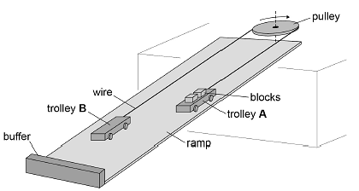

**Figure 1**

The model consists of two identical trolleys of mass ***M***on a ramp which is at 35° to the horizontal. The trolleys are connected by a wire that passes around a pulley of negligible mass at the top of the ramp.

Two concrete blocks each of mass ***m***are loaded onto trolley **A** at the top of the ramp. The trolley is released and *accelerates* to the bottom of the ramp where it is stopped by a flexible buffer. The blocks are unloaded from trolley **A** and two blocks are loaded onto trolley **B** that is now at the top of the ramp. The trolleys are released and the process is repeated.

**Figure 2** shows the side view of trolley **A** when it is moving **down** the ramp.

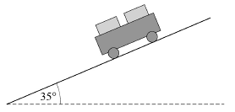

**Figure 2**

The tension in the wire when the trolleys are moving is **T**.

Assume that no friction acts and that air resistance is negligible.

1. (i) Draw and label arrows on **Figure 2** to represent the magnitudes and directions of any forces that act on trolley **A** *parallel* to the ramp as it travels down the ramp.

(2 marks)

(ii) Write an expression in terms of M, m and g for the force of gravity acting on trolley **A** *parallel* to the ramp as it travels down the ramp. (2 marks)

..........................................................................................................................................

..........................................................................................................................................

..........................................................................................................................................

(iii) Show that the net acceleration ***a***of trolley **A** along the ramp is given by

(3 marks)

..........................................................................................................................................

..........................................................................................................................................

..........................................................................................................................................

..........................................................................................................................................

..........................................................................................................................................

..........................................................................................................................................

..........................................................................................................................................

..........................................................................................................................................

**Question 13 (9 marks)**

An electron is emitted from a mineral sample, and travels through aperture **A** into a spectrometer at an angle of 60.0° with a speed of 6.00 x 106 m s–1.

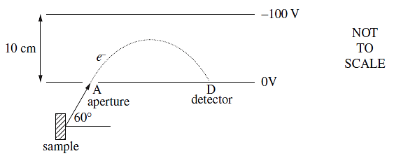

1. Calculate the magnitude and direction of the force experienced by the electron inside the spectrometer. (3 marks)

..........................................................................................................................................

..........................................................................................................................................

..........................................................................................................................................

1. The electron experiences constant acceleration and eventually strikes the detector, **D**.

What is the time taken for the electron to travel from **A** to **D**? (4 marks)

..........................................................................................................................................

..........................................................................................................................................

..........................................................................................................................................

..........................................................................................................................................

..........................................................................................................................................

..........................................................................................................................................

..........................................................................................................................................

..........................................................................................................................................

..........................................................................................................................................

..........................................................................................................................................

1. Calculate the distance between **A** and **D**. (2 marks)

..........................................................................................................................................

..........................................................................................................................................

..........................................................................................................................................

..........................................................................................................................................

**Question 14 (18 marks)**

1. **Figure 1** shows two magnets, supported on a yoke, placed on an electronic balance.

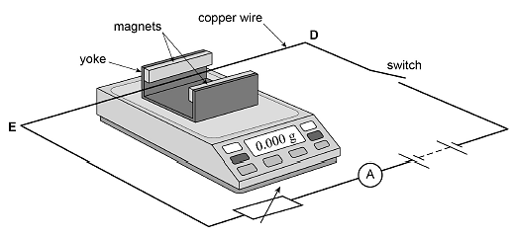

**Figure 1**

The magnets produce a uniform horizontal magnetic field in the region between them. A copper wire **DE** is connected in the circuit shown in **Figure 1** and is clamped horizontally at right angles to the magnetic field.

**Figure 2** shows a simplified plan view of the copper wire and magnets.

**Figure 2**

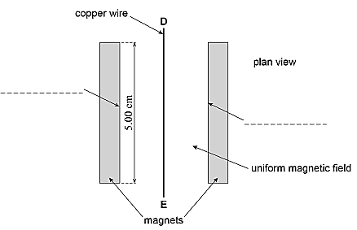

When the apparatus is assembled with the switch open, the reading on the electronic balance is set to 0.000 g. This reading changes to a positive value when the switch is closed.

1. Which of the following correctly describes the direction of the force acting on the wire **DE** due to the magnetic field when the switch is closed?

Tick (✓) the correct box. (1 mark)

|  |  |
| --- | --- |
| towards the left magnet in Figure 2 |  |
| towards the right magnet in Figure 2 |  |
| vertically up |  |
| vertically down |  |

1. Label the poles of the magnets by putting **N** or **S** on each of the two dashed lines in **Figure 2**. Draw the magnetic field between the magnets. [Use a minimum of 6 lines of flux.] (2 marks)
2. Define the unit tesla. (2 marks)

..........................................................................................................................................

..........................................................................................................................................

..........................................................................................................................................

1. The magnets are 5.00 cm long. When the current in the wire is 3.43 A the reading on the electronic balance is 0.620 g. Assume the field is uniform and is zero beyond the length of the magnets.

Calculate the magnetic flux density between the magnets. (2 marks)

..........................................................................................................................................

..........................................................................................................................................

..........................................................................................................................................

1. A cyclotron has two D-shaped regions where the magnetic flux density is constant. The D-shaped regions are separated by a small gap.

An alternating electric field between the D-shaped regions accelerates charged particles. The magnetic field causes the charged particles to follow a circular path.

**Figure 3** shows the path followed by **a proton** that starts from **O**.

Magnetic field: 0.44 T ∆V between “D”s: 186000 V

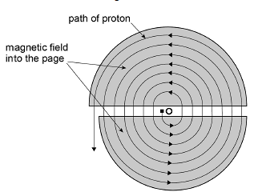

**Figure 3**

1. Show clearly on Figure 3 the direction of the magnetic fields in the D-shaped regions.

(1 mark)

1. Explain why it is **not** possible for the magnetic field to alter the speed of a proton while it is in one of the D-shaped regions. (2 marks)

..........................................................................................................................................

..........................................................................................................................................

..........................................................................................................................................

..........................................................................................................................................

..........................................................................................................................................

1. When the proton crosses the gap between the “D”s, how much energy does it gain?

(2 marks)

..........................................................................................................................................

..........................................................................................................................................

..........................................................................................................................................

1. The maximum radius of the path followed by the proton is 0.85 m and the magnetic flux density of the uniform field is 0.44 T.

Calculate the maximum speed of a proton when it leaves the cyclotron. (2 marks)

*Ignore any relativistic effects*.

..........................................................................................................................................

..........................................................................................................................................

..........................................................................................................................................

..........................................................................................................................................

Is the assumption: “*Ignore any relativistic effects*.” reasonable? Explain briefly.

(1 mark)

..........................................................................................................................................

..........................................................................................................................................

The following expression for the cyclotron frequency is independent of the radius of the path.

A synchrocyclotron is a cyclotron in which the frequency of the driving electric field is varied to compensate for relativistic effects as the particles' velocity begins to approach the speed of light. This is in contrast to the classical cyclotron, where the frequency was held constant.

Assuming that the correction is necessary, calculate the cyclotron frequency.

(3 marks)

..........................................................................................................................................

..........................................................................................................................................

..........................................................................................................................................

..........................................................................................................................................

..........................................................................................................................................

..........................................................................................................................................

..........................................................................................................................................

**Question 15 (16 marks)**

1. The following makeshift device, **Figure 1**, was made to provide lighting for a stranded astronaut on Mars.

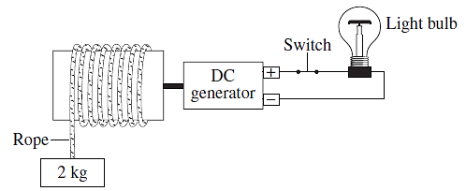

**Figure 1**

Explain the difference in the behaviour of the falling mass when the switch is open compared to when it is closed. (3 marks)

..........................................................................................................................................

..........................................................................................................................................

..........................................................................................................................................

..........................................................................................................................................

..........................................................................................................................................

..........................................................................................................................................

..........................................................................................................................................

1. The alternator in **Figure 2** has a rectangular coil, with sides of 0.30 m x 0.40 m, and 10 turns. The coil rotates 240 times a minute in a uniform magnetic field. The magnetic flux intensity through the coil in the position shown is 0.20 T.

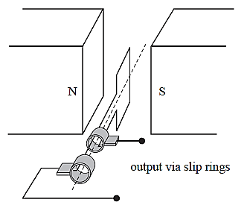

A

B

C

D

***X***

***Y***

**Figure 2**

1. Calculate the magnitude of the peak EMF (*ε*) generated. (2 marks)

..........................................................................................................................................

..........................................................................................................................................

..........................................................................................................................................

..........................................................................................................................................

**Figure 3** shows the output EMF (*ε*) versus time graph of the alternator for two complete cycles.

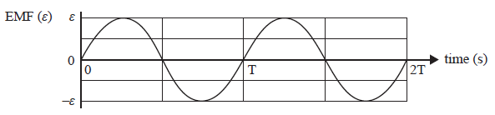

**Figure 3**

1. On **Figure 3** show a point that corresponds to the EMF at the point of rotation shown in **Figure 2.** (1 mark)

The two slip rings in **Figure 2** are now replaced with a split-ring commutator.

1. On the axes provided below, sketch the EMF (*ε*) versus time graph of this new arrangement for two complete cycles. (2 marks)

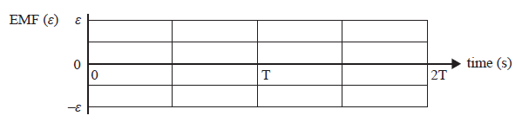

Again refer to **Figure 2.**

1. Describe the orientation and movement of the coil ABCD so that the output slip ring ***X*** is + (positive) and the output slip ring ***Y*** is – (negative). (2 marks)

..........................................................................................................................................

..........................................................................................................................................

..........................................................................................................................................

..........................................................................................................................................

..........................................................................................................................................

|  |  |
| --- | --- |
| (c) (i) **Figure 4** shows lines of force for the electric field surrounding two charged objects  **L** and **M**.  **N** is a point between **L** and **M**. | **Figure 4** |

State which object **L** or **M** has a charge with the greater magnitude. ………………

State which object **L** or **M** has a positive charge. ….……..……

(1 mark)

Explain why the lines of force shown in **Figure 4** cannot represent a gravitational field.

(2 marks)

..........................................................................................................................................

..........................................................................................................................................

..........................................................................................................................................

..........................................................................................................................................

(ii) An AC source is connected to a transformer having a primary winding of 900 turns. Connected to the secondary winding of 450 turns is a pair of parallel plates 0.010 m apart.

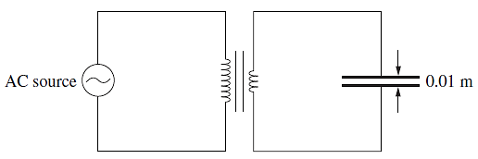

The AC input is shown in the graph.

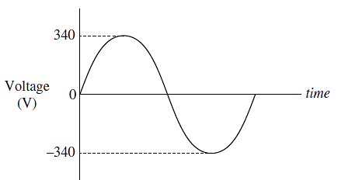

What is the maximum field strength (in V m–1) produced between the plates?

(2 marks)

..........................................................................................................................................

..........................................................................................................................................

..........................................................................................................................................

..........................................................................................................................................

(iii) The diagram shows a DC circuit containing a transformer.

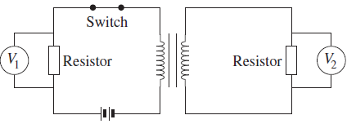

The potential differences *V*1 and *V*2 are measured continuously for 4 s.

The switch is initially closed. At *t* = 2 s, the switch is opened.

Which pair of graphs shows how the potential differences *V*1 and *V*2 vary with time over the 4-second interval? Circle the correct answer. (1 mark)

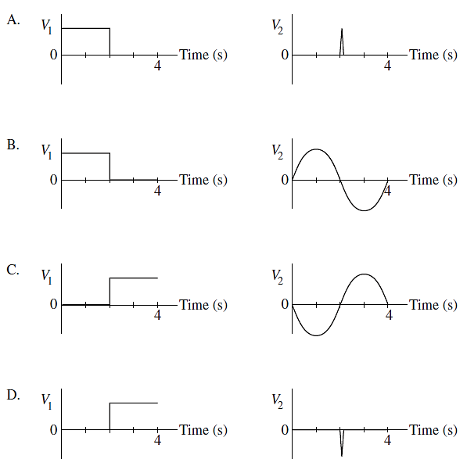

**Question 16 (14 marks)**

|  |  |
| --- | --- |
| (a)An aurora is the appearance of brilliant coloured 'curtains' of light in the sky near the north and south poles.  Particles discharged from the sun, known as the Solar Wind, travel toward Earth before they are drawn irresistibly toward the magnetic north and south poles. As the particles pass through the [Earth's magnetic shield](https://www.space.com/11187-earth-magnetic-field-solar-wind.html), they mingle with atoms and molecules of oxygen, nitrogen and other elements that result in the dazzling display of lights in the sky. |  |

Typically, when the particles collide with oxygen, yellow and green are produced. Interactions with nitrogen produce red, violet, and occasionally blue colours.

Carefully explain, using physics principles, how and why auroras occur and the reason for the different colours. (4 marks)

..........................................................................................................................................

..........................................................................................................................................

..........................................................................................................................................

..........................................................................................................................................

..........................................................................................................................................

..........................................................................................................................................

..........................................................................................................................................

..........................................................................................................................................

..........................................................................................................................................

..........................................................................................................................................

1. Consider some of the energy levels for Neon given below.

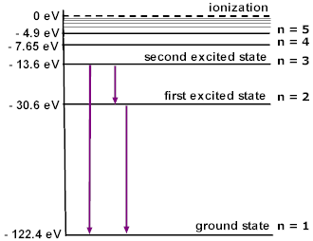

1. Consider the 3 transitions shown.

Would these transitions shown be part of an *absorption* or *emission* spectrum?

Circle the correct answer. (1 mark)

Indicate on the diagram the transition with the longest wavelength using the letter ***L***.

Calculate this wavelength.

Is this a photon of visible light? If not, in what region of the electromagnet spectrum would it be found? (4 marks)

….......................................................................................................................................

….......................................................................................................................................

….......................................................................................................................................

….......................................................................................................................................

….......................................................................................................................................

….......................................................................................................................................

….......................................................................................................................................

1. State what would emerge from a sample of neon gas when it is bombarded by the following photons or particles. (5 marks)

|  |  |
| --- | --- |
| **Bombarding photons or particles** | **Emerging photons or particles (eV)** |
| Photons of 114.75 eV |  |
| Electrons of 110 eV |  |

**Question 17 (11 marks)**

In an experiment, blue light of frequency 6.25 x 1014 Hz is shone onto the sodium cathode of a photocell. The apparatus is shown in Figure 1 below.

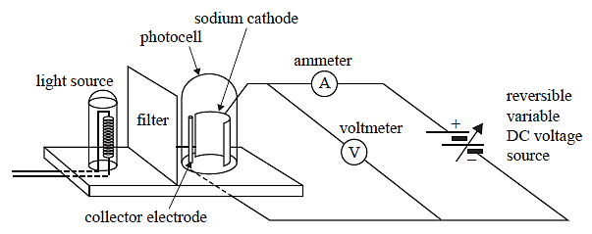

**Figure 1**

The graph of photoelectric current versus potential difference across the photocell is shown in Figure 2.

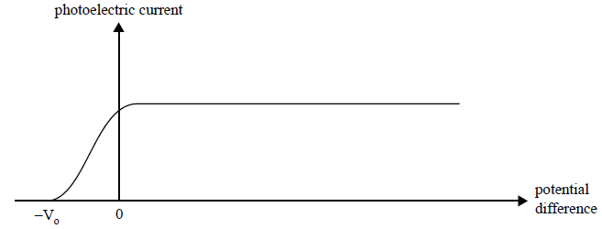

**Figure 2**

The threshold frequency for sodium is 5.50 x 1014 Hz.

1. Determine the maximum speed of the ejected electrons. (3 marks)

..........................................................................................................................................

..........................................................................................................................................

..........................................................................................................................................

..........................................................................................................................................

..........................................................................................................................................

..........................................................................................................................................

..........................................................................................................................................

..........................................................................................................................................

1. What is the cut-off potential, Vo, when blue light of frequency 6.25 x 1014 Hz is shone onto the sodium cathode of the photocell referred to in Figures 1 and 2? (2 marks)

..........................................................................................................................................

..........................................................................................................................................

..........................................................................................................................................

..........................................................................................................................................

….......................................................................................................................................

1. On the graph of photoelectric current versus potential difference shown in Figure 2, sketch the curve expected if the light is changed to **ultraviolet** with a **higher intensity** than the original blue light. (2 marks)
2. The results of photoelectric effect experiments in general provide strong evidence for the particle-like nature of light.

Outline **two** aspects of these results that provide the strong evidence that is not explained by the wave model of light, and explain why. (4 marks)

..........................................................................................................................................

..........................................................................................................................................

..........................................................................................................................................

..........................................................................................................................................

..........................................................................................................................................

..........................................................................................................................................

..........................................................................................................................................

..........................................................................................................................................

..........................................................................................................................................

..........................................................................................................................................

..........................................................................................................................................

..........................................................................................................................................

**Question 18 (15 marks)**

1. Tests of relativistic time dilation have been made by observing the decay of short-lived particles. A muon, travelling from the edge of the atmosphere to the surface of Earth, is an example of such a particle.

To model this in the laboratory, another elementary particle with a shorter half-life is produced in a particle accelerator. It is travelling at 0.99875*c*. Scientists observe that this particle travels 9.14 × 10–5 m in a straight line from the point where it is made to the point where it decays into other particles. It is not accelerating.

1. Calculate the lifetime of the particle in the scientists’ frame of reference. (2 marks)

..........................................................................................................................................

..........................................................................................................................................

..........................................................................................................................................

..........................................................................................................................................

1. Calculate the distance that the particle travels in the laboratory, as measured in the particle’s frame of reference. (2 marks)

..........................................................................................................................................

..........................................................................................................................................

..........................................................................................................................................

..........................................................................................................................................

1. Explain why the scientists would observe more particles at the end of the laboratory measuring range than classical physics would expect. (2 marks)

..........................................................................................................................................

..........................................................................................................................................

..........................................................................................................................................

..........................................................................................................................................

..........................................................................................................................................

..........................................................................................................................................

1. A space probe speeding towards the nearest star moves at 0.250c and sends radio information at a broadcast frequency of 1.00 GHz.
2. At what speed is the radio signal received on the Earth? Explain briefly. (2 marks)

..........................................................................................................................................

..........................................................................................................................................

..........................................................................................................................................

1. What frequency is received on the Earth? (2 marks)

..........................................................................................................................................

..........................................................................................................................................

..........................................................................................................................................

..........................................................................................................................................

..........................................................................................................................................

..........................................................................................................................................

..........................................................................................................................................

1. If two spaceships A and B are heading directly towards each other at 0.80c. A canister is shot from the first ship A at 0.25c, as measured in A's frame of reference.
2. How fast will an external stationary observer see the projectile travelling? (2 marks)

..........................................................................................................................................

..........................................................................................................................................

..........................................................................................................................................

..........................................................................................................................................

..........................................................................................................................................

..........................................................................................................................................

1. How fast will B see the projectile approaching? (2 marks)

..........................................................................................................................................

..........................................................................................................................................

..........................................................................................................................................

..........................................................................................................................................

..........................................................................................................................................

..........................................................................................................................................

1. In a thought experiment, a train is moving at a constant speed of 0.8*c*. A lamp is located at the midpoint of a carriage. There are doors *W* and *Z* at each end of the carriage which open automatically when light from the lamp reaches them.

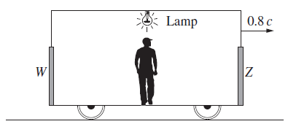

The passenger standing at the midpoint of the carriage switches on the lamp.

Which statement best explains what the passenger observes about the doors? (1 mark)

(A) *Z* opens before *W* because the lamp is moving towards *Z.*

(B) *W* opens before *Z* because *W* is moving towards the lamp.

(C) *W* and *Z* open simultaneously because the lamp is placed at an equal distance from both.

(D) *W* and *Z* open simultaneously because the distance from the lamp to each door has contracted by the same amount.

**Question 19 (8 marks)**

1. **Figure 1** shows how the distance to a nearby star X can be determined using trigonometric parallax. E1 and E2 are the positions of the Earth in its orbit around the Sun in March and September, i.e. six months apart.

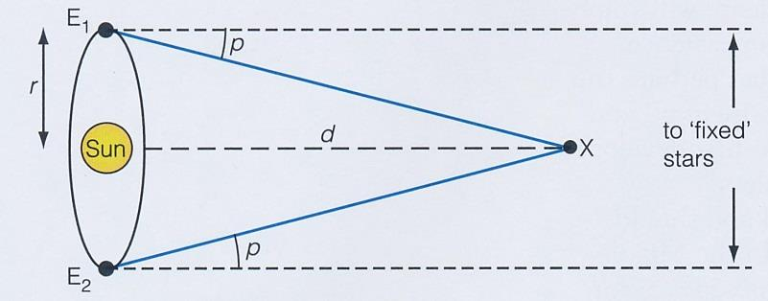

**Figure 1**

Taking *r* to be 1 AU, calculate the parallax angle *p* in degrees for a star that is 240 light years away. [1 year = 365.25 days.] (3 marks)

..........................................................................................................................................

..........................................................................................................................................

..........................................................................................................................................

..........................................................................................................................................

..........................................................................................................................................

..........................................................................................................................................

1. **Figure 2** shows a typical galaxy like the Milky Way, seen from 'the side'. The speed *v* of star S as it moves round the centre of the galaxy can be measured, as can the distance *r*.

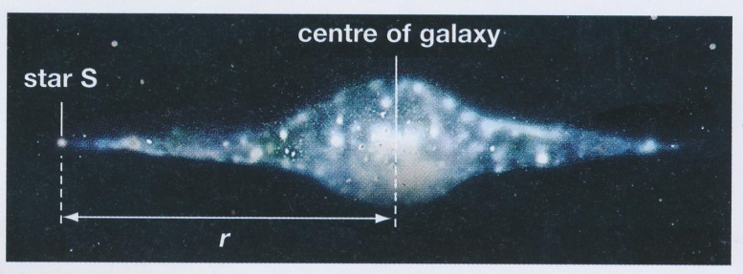

**Figure 2**

1. **Figure 2** shows the stars in the galaxy detected by an optical telescope. What celestial objects would be detected by a telescope receiving EMR in the:
2. uv range?

..........................................................................................................................................

1. X-ray range?

..........................................................................................................................................

..........................................................................................................................................

(2 marks)

1. The mass of the galaxy can be calculated using the formula:

However the mass of the galaxy turns out to be much bigger than the mass expected by studying the luminosity of the galaxy. How do cosmologists explain this difference?

(3 marks)

..........................................................................................................................................

..........................................................................................................................................

..........................................................................................................................................

..........................................................................................................................................

..........................................................................................................................................

..........................................................................................................................................

..........................................................................................................................................

..........................................................................................................................................

**This page has been left blank intentionally.**

**Section Three: Comprehension 20% (36 Marks)**

This section has two (2) questions. Write your answers in the spaces provided.

Spare pages are included at the end of this booklet. They can be used for planning your responses and/or as additional space if required to continue an answer.

Suggested working time: 40 minutes.

**Question 20 (19 marks)**

An experiment is set up to investigate how the motion of a sphere on a track depends on the radius of curvature of the track.

The apparatus is set up as shown in **Figure 1**.

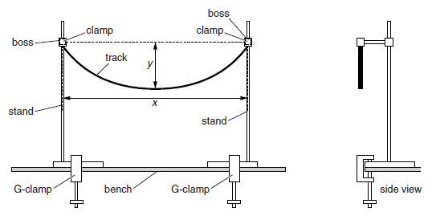

**Figure 1**

1. The radius of curvature *R* of the track is calculated by



One set of data has x = 91.5 cm and y = 18 cm. Calculate the radius of curvature *R, in cm,* of the track, including the absolute error. Express your answer to the appropriate number of significant figures . (4 marks)

..........................................................................................................................................

..........................................................................................................................................

..........................................................................................................................................

..........................................................................................................................................

..........................................................................................................................................

..........................................................................................................................................

..........................................................................................................................................

A ball rolls forwards and backwards on a curved track as shown in **Figure 2**.

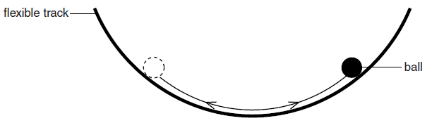

It is suggested that the period ***T***of the oscillations is related to the radius ***r***of the ball and the radius of curvature ***R***of the track by the relationship:

where *g* is the acceleration of free fall.

1. The period ***T***of the oscillations was calculated by timing 5 oscillations of the ball, repeating the trial, and averaging the results. What is the reason for each of the underlined steps? (2 marks)

..........................................................................................................................................

..........................................................................................................................................

..........................................................................................................................................

..........................................................................................................................................

..........................................................................................................................................

The Table of Results is as follows:

|  |  |  |
| --- | --- | --- |
| ***av T***  (s) | ***R***  (cm) | ***T2*** |
| 1.28 ± 10% | 42 |  |
| 1.55 ± 10% | 53 |  |
| 1.61 ± 10% | 58 |  |
| 2.09 ± 10% | 83 |  |

1. Calculate the values of ***T2***, including the absolute error. Record them in the Table. (4 marks)

(d) Graph ***T2*** , including the **ONE** error bar for ***R*** = 53 cm, on the y-axis and ***R*** on the x-axis on the graph paper on the next page. Additional graph paper is supplied at the end of this question if required. (4 marks)

1. Draw the line of best fit. (2 marks)

***R***

(cm)

**0**



***R***

(cm)

**0**

1. Determine the radius ***r***of the ball. Show your working clearly. (3 marks)

..........................................................................................................................................

..........................................................................................................................................

..........................................................................................................................................

..........................................................................................................................................

..........................................................................................................................................

..........................................................................................................................................

..........................................................................................................................................

**Question 21 (21 marks)**

**THE STRONG INTERACTION**

Before the 1970s, physicists were uncertain as to how the atomic nucleus was bound together. It was known that the nucleus was composed of protons and neutrons and that while neutrons were electrically neutral, protons possessed positive electric charge. Since positive charges would repel one another the positively charged protons should cause the nucleus to fly apart. A stronger attractive force was postulated to explain how the atomic nucleus was bound together. This hypothesized force was called the *strong force*, which was believed to be a fundamental force that acted on the protons and neutrons that make up the nucleus.

It was later discovered that protons and neutrons were not fundamental particles but were made up of constituent particles called quarks. The strong attraction between nucleons was the side-effect of a more fundamental force that bound the quarks together into protons and neutrons. Quarks attract one another due to the **strong interaction**, and the particle that mediates this is called the gluon.

The word *strong* is used since the strong interaction is the "strongest" of the four fundamental forces. At a distance of 1 femtometre (1fm = 10−15 meters) or less, its strength is around 137 times that of the electromagnetic force, some 106 times as great as that of the weak force, and about 1038 times that of gravitation.

The force carrier particle of the strong interaction is the gluon, a massless boson. Unlike the photon in electromagnetism, which is neutral, the gluon carries a colour charge (not to be confused with electrical charge). Quarks and gluons are the only fundamental particles that carry colour charge, and hence they participate in strong interactions only with each other. The strong force is the expression of the gluon interaction with other quark and gluon particles.

Unlike all other forces (electromagnetic, weak, and gravitational), the strong force between quarks does not diminish in strength with increasing distance between pairs of quarks. After a limiting distance (about the size of a hadron) has been reached, it remains at a strength of about 10,000 N no matter how much farther the distance between the quarks. As the separation between the quarks grows, the work done against this force and hence the energy required to pull the two quarks apart will create a pair of new quarks that will pair up with the original ones; hence it is impossible to create separate quarks. As a result only hadrons, not individual free quarks, can be observed. The failure of all experiments that have searched for free quarks is evidence of this phenomenon.

|  |  |
| --- | --- |
| In hadrons, the colour-charge of the quarks essentially cancels out, and the strong force is therefore nearly absent between hadrons except that the cancellation is not quite perfect. A residual force remains, known as the **residual strong force,** or the **strong nuclear force** or simply the **nuclear force**. The strong nuclear force is thus a minor residuum of the strong force that binds quarks together into protons and neutrons.  This same force is much weaker *between* neutrons and protons, because it is mostly neutralized *within* them, in the same way that electromagnetic forces between neutral atoms | **Figure 1**  elated image |

(van der Waals forces) are much weaker than the electromagnetic forces that hold electrons to the nucleus, forming the atoms.

This residual force *does* diminish rapidly with distance, approximately as a negative exponential power of distance, and is thus very short-range (effectively a few femtometres). The rapid decrease with distance of the attractive residual strong force, and the less-rapid decrease of the repulsive electromagnetic force acting between protons, causes the instability of larger atomic nuclei, such as all those with atomic numbers larger than 82 (the element lead).

|  |  |
| --- | --- |
| In theoretical physics, **Feynman diagrams** are pictorial representations of the mathematical expressions describing the behaviour of subatomic particles. The scheme is named after its inventor, American physicist Richard Feynman, and was first introduced in 1948. The interaction of sub-atomic particles can be complex and difficult to understand intuitively. Feynman diagrams give a simple visualization of what would otherwise be an arcane and abstract formula. | Image result for feynman diagram showing gluons  **Figure 2** |

As David Kaiser writes, "since the middle of the 20th century, theoretical physicists have increasingly turned to this tool to help them undertake critical calculations", and so "Feynman diagrams have revolutionized nearly every aspect of theoretical physics". While the diagrams are applied primarily to quantum field theory, they can also be used in other fields, such as solid-state theory.

**Questions**

(a) The hydrogen atom consists of an electron bound to a proton by electromagnetic attraction. Explain why each of the following forces does not help hold a hydrogen atom together.

1. strong interaction (2 marks)

..........................................................................................................................................

..........................................................................................................................................

..........................................................................................................................................

1. gravitation (2 marks)

..........................................................................................................................................

..........................................................................................................................................

..........................................................................................................................................

..........................................................................................................................................

1. Explain why free quarks have not been observed, and why it is thought impossible for them to be separated from one another. (4 marks)

..........................................................................................................................................

..........................................................................................................................................

..........................................................................................................................................

..........................................................................................................................................

..........................................................................................................................................

..........................................................................................................................................

..........................................................................................................................................

..........................................................................................................................................

1. Describe the relationship between the strong force and the residual strong force (the strong nuclear force). (4 marks)

..........................................................................................................................................

..........................................................................................................................................

..........................................................................................................................................

..........................................................................................................................................

..........................................................................................................................................

..........................................................................................................................................

..........................................................................................................................................

..........................................................................................................................................

1. Explain why atomic nuclei with atomic numbers larger than 82 are unstable. (4 marks)

..........................................................................................................................................

..........................................................................................................................................

..........................................................................................................................................

..........................................................................................................................................

..........................................................................................................................................

..........................................................................................................................................

..........................................................................................................................................

..........................................................................................................................................

1. Consider **Figure 2 on page 36.** Name the exchange particle shown in the Feynman diagram.

(1 mark)

..........................................................................................................................................

**End of Examination**



***R***

(cm)

**0**

Spare Paper

..........................................................................................................................................

..........................................................................................................................................

..........................................................................................................................................

..........................................................................................................................................

..........................................................................................................................................

..........................................................................................................................................

..........................................................................................................................................

..........................................................................................................................................

..........................................................................................................................................

..........................................................................................................................................

..........................................................................................................................................

..........................................................................................................................................

..........................................................................................................................................

..........................................................................................................................................

..........................................................................................................................................

..........................................................................................................................................

..........................................................................................................................................

..........................................................................................................................................

..........................................................................................................................................

..........................................................................................................................................

..........................................................................................................................................

..........................................................................................................................................

..........................................................................................................................................

..........................................................................................................................................

..........................................................................................................................................

..........................................................................................................................................

..........................................................................................................................................

..........................................................................................................................................

..........................................................................................................................................

..........................................................................................................................................

..........................................................................................................................................

..........................................................................................................................................

..........................................................................................................................................

..........................................................................................................................................

..........................................................................................................................................

..........................................................................................................................................

..........................................................................................................................................

..........................................................................................................................................

..........................................................................................................................................

..........................................................................................................................................

..........................................................................................................................................

..........................................................................................................................................

..........................................................................................................................................

..........................................................................................................................................

..........................................................................................................................................

..........................................................................................................................................

..........................................................................................................................................

..........................................................................................................................................

..........................................................................................................................................

..........................................................................................................................................

..........................................................................................................................................

..........................................................................................................................................

..........................................................................................................................................

..........................................................................................................................................

..........................................................................................................................................

..........................................................................................................................................

..........................................................................................................................................